Posture Guard : Gym Injury Prediction and Prevenetion

Tanishka Goel   
Department of Computer Science and Engineering  
KIET Group of InstitutionsGhaziabad, India  
26tanishkagoel@gmail.com

Rahul Kumar Sharma  
Department of Computer Science and Engineering  
KIET Group of InstitutionsGhaziabad, India  
rahulpccs1988@gmail.comSakshi Jain  
Department of Computer Science and Engineering  
KIET Group of InstitutionsGhaziabad, India  
jainsakshi1148@gmail.com

Vasu Bansal  
Department of Computer Science and Engineering  
KIET Group of InstitutionsGhaziabad, India  
vasubansal12002@gmail.com

*Abstract*—This study presents Posture Guard a cutting-edge device intended to anticipate and avoid gym injuries. Posture Guard uses machine learning techniques and cutting-edge sensor technology to continuously monitor users' biomechanics while they exercise. By analyzing real time data, the system may identify potential problems linked to bad posture and promptly offers users with feedback, encouraging safer workout behaviors. Posture Guard intends to proactively reduce the risk of gym-related injuries by incorporating predictive analytics, providing a useful tool for both exercise amateurs and experts. The subject of technology driven injury prevention in exercise facilities is a young one, and our research adds to it. An inventive gym safety device called Posture Guard aims to anticipate and stop injuries caused by improper workout postures. Using wearable and equipment-integrated sensors, the system tracks users' movements in real time and provides feedback via a mobile application. By giving users, the ability to make quick modifications, this instantaneous advice reduces the chance of injuries brought on by bad posture. Posture Guard uses sophisticated machine learning algorithms to generate user-specific profiles that improve forecast accuracy over time by adjusting to each user's specific biomechanics. By using past data, the technology not only detects deviations from ideal postures but also proactively forecasts possible injury risks, allowing for prompt intervention.

Keywords—machine learning, real-tine data, exercise safety, workout monitoring

# Introduction

The popularity of gyms and fitness centres has increased in the modern pursuit of a better and more active lifestyle, indicating a growing understanding of the significance of physical well-being. These areas provide as havens for those pursuing a variety of fitness objectives, such as cardiovascular health, strength training, and weight control. The benefits of consistent exercise are undeniable, but there is always a risk of injury during physical activity, which calls for creative solutions.

A healthy lifestyle is centred around physical activity, and fitness centres are essential for supporting fitness goals. But the possibility of getting hurt when working out at the gym is a recurring worry that can impede development and jeopardise people's health. In order to solve this issue, the Posture Guard project has developed a comprehensive system that makes use of state-of-the-art technologies in order to forecast and prevent injuries related to poor posture during exercise.



The "Posture Guard" project is a ground-breaking endeavour that has the potential to completely transform the field of injury prevention in gym settings. This research aims to utilise sophisticated technology to predict and prevent exercise-related injuries, as most of these accidents are caused by incorrect posture and biomechanics. By doing this, it not only solves the pressing issue of preventing injuries but also advances the larger thesis of improving the general efficacy and safety of exercise regimens.

The risk of injury increases as people participate in a wide range of activities, such as functional training, flexibility exercises, and cardiovascular workouts in addition to weightlifting. Conventional methods, which frequently depend on human observation and broad recommendations, are unable to offer individualised, real-time feedback that is specific to a person's own biomechanics and exercise regimen. By combining biomechanical knowledge, state-of-the-art sensor technology, and artificial intelligence, the Posture Guard project closes this crucial gap by developing a comprehensive system that can track, evaluate, and react to users' postures while they exercise.

The importance of this endeavour is highlighted by the rising number of injuries sustained in the gym, which are frequently caused by improper form, overexertion, or wrong posture adoption. These injuries discourage people from keeping up regular exercise routines since they not only make it difficult to reach fitness objectives but also have the potential to cause long-term health issues. By providing a proactive solution that gives people the confidence to exercise knowing that their postures are constantly being checked and optimised for injury avoidance, the Posture Guard project aims to completely rethink this paradigm.

Our initiative takes front stage in this setting, hoping to revolutionise the fitness technology market by providing a complete solution that extends beyond progress tracking. The main goal of the "Posture Guard – Gym Injury Prediction and Prevention" project is to provide a dynamic and adaptable training platform by utilising cutting-edge technical approaches. This platform is intended to help people reach their fitness objectives more successfully while also lowering the chance of injury. In order to prevent injuries and guarantee the efficacy of the workouts, the suggested solution would provide real-time feedback on form and technique as well as personalised workout recommendations based on the user's fitness level and injury susceptibility.

# Literature Review

Exercise-related injuries are frequently associated with bad form, poor posture, and overexertion. Even in the presence of fitness instructors and instructions, people may unintentionally assume improper postures that result in either acute or chronic injuries. The Posture Guard idea is born out of a growing fitness culture and aims to address the ongoing problem of injuries sustained in the gym. Even with fitness coaching readily available, bad posture during exercise remains a major cause of injury. This research combines biomechanics and technology to reduce the hazards that come with improper workout postures in advance.

Laplaza, Javier, et al, [1] says in Human-Robot Interaction, finding natural and effective communication routes is critical. Gesture-based language allows people to connect with robots in a natural way by utilizing their bodies. To train our network, we used neural networks and a specific dataset of individuals executing a series of body motions. Huang, Xiaoping, et al, [2] says Recognizing postures without invading privacy, expensive costs, and difficult implementation procedures, as well as raising recognition rate for stationary postures, which is not achievable with acceleration sensor techniques. The construction of a single deployed indoor location system involves the placement of wearable receiving tags at key locations on the body. Furthermore, the enhanced extended Kalman filtering (iEKF) algorithm and the least square estimation (LSE) technique are employed. The iEKF algorithm outperforms the LSE technique in terms of accuracy. The system's robustness and stability are also commendable. Work on developing wearable technology has the potential to increase overall process accuracy. Abedi, et al, [3] says Convolutional neural networks are used in a vision-based method for one-person posture identification to identify and categorize several classes for the human posture. Numerous algorithms are given, divided into groups such computer vision-based algorithms and algorithms based on wearable sensors and ambient devices. The learned CPN's ideas increase the accuracy of the findings by employing four distinct scales and aspect ratios for each. Real-time recognition is becoming better.

Gjoreski, Hristijan, et al, [4] says Accelerometer-based fall detection that uses posture recognition to identify postures that might be the outcome of both fall detection and posture recognition. By determining whether the posture may be the consequence of a fall, the posture recognition techniques were applied to enhance fall detection. Using the appropriate methodologies, good accuracy was often attained in both fall detection and posture detection, and potential issues are discovered and highlighted. Dimitrijevic, et al, [5] says Method for spotting human silhouettes in a certain walking position. include 2D silhouette sequences generated from motion capture data.

Employ statistical learning methodologies to compute and document the importance of the numerous silhouette constituents to the identification task. They apply at runtime to transform Chamfer distance into useful probability estimates. Capable of producing extremely favourable outcomes for both outdoor and indoor sequences when backdrop removal is not feasible in conditions with poor illumination, several camera viewpoints, and noticeable scale variations. Song, et al, [6] says to develop a novel technique to gesture recognition, which constantly recognizes movements from an unsegmented and unbounded input stream while tracking the hands and torso simultaneously.

The system begins by collecting RGBD pictures from a single stereo camera. 1 As it receives the photos, it does background removal using a mix of a codebook technique and a depth-cut method, i.e., once a likely region-of interest is identified. Presented a novel method for gesture identification that concurrently tracks the body and hands, detects gestures continuously from an unsegmented and unbounded input stream, and described our latest work on deep-hierarchical sequence representation learning and multimodal gesture recognition, which achieves the best results on several real-world datasets. Gunes, et al, [7] says to create technology that effectively records and understands human movement, body behaviour, and face expression.

It investigates four areas of subproblem solutions in automated facial expression analysis and classification: a database of Ekman-Hager facial action exemplars. Detecting and/or monitoring the face in a facial picture or image sequence is a vastly unexplored domain, and creating automatic facial expression analysis computes the output data expressions. The study initially reviewed several methodologies and past work in autonomous facial expression/action analysis, gesture detection, and multimodal interfaces before offering a concept for a vision-based multimodal analyser that identifies face and body gesture.

Goldmann, et al, [8] says in order to handle various analytical tasks, such as its goals are to identify, track, identify actions, and characterize individual bodily components as well as the person in their entirety. The technology that is being considered makes use of me. For this multiclass problem, several hierarchical and non-hierarchical approaches were examined, and a system structure was drawn. After the object was isolated from the background using contour-based shape descriptor (CBSD), one of the shape descriptors, experiments were carried out. Present a novel way to recognizing human body position. Its base is the projection histogram and the MPEG-7 shape definition. A combination of them was used to identify the primary posture and view of a human, based on the binary object mask that was produced following the segmentation procedure. Additionally, Pisharady, et al, [9] says using geometric characteristics from the Kinect for a multi-class human posture detection and identification method. The collected characteristics correspond to 11 vectors defined by 14 human skeleton points. Postures are detected by thresholding the likelihood of the stance. An SVM classifier is used for classification. The system incorporating positional characteristics has a recognition accuracy of 74.08%, emphasizing the significance of the proposed method's scale. Using Kinect-based geometrical characteristics, a person, location, and scale invariant posture detection and identification technique are suggested. The collected characteristics correspond to 11 vectors defined by 14 human skeleton points. Postures are detected by thresholding the likelihood of the stance.

Dimitrijevic, et al, [10] says to demonstrate a template-based method for recognizing human silhouettes in a specified walking stance. As templates, brief sequences of 2D silhouettes obtained from motion capture data are used. This allows it to include motion data in them and distinguishes real individuals who move in regular patterns from static items whose outlines are generally similar to those belonging to people. Additionally, statistical learning techniques are employed in the training phase to measure and store the relative importance of different silhouette aspects to the recognition task. The research developed a template-based technique for detecting human body poses. The templates are created using a virtual figure that makes genuine human gestures that are collected by a motion capture device. Despite not using colour or texture, it has demonstrated extremely strong performance for indoor and outdoor sequences when backdrop removal is not feasible in situations with poor lighting, multiple camera viewpoints, or apparent size variations.

Shirehjini, et al, [11] says the pressure sensors installed in the chair allow the system to discriminate between different positions based on the presence of imposed pressure. The data is subsequently sent into a decision engine, which determines the sitting person's condition. We have demonstrated the Aware Chair system, which can recognize a seated person's body position using only 8 binary pressure sensors. Because the sensors in some situations require direct pressure to be activated, the readings are mismatched, thus we aim to experiment with various types of sensors whose sensitivity may be modified to fit the application's needs.

Van den Bergh, et al, [12] says in this paper, we provide a unique method for marker less real-time posture detection in a multi-camera configuration. Body posture is extracted using example-based classification based on Haar wavelet-like features to enable real-time pose detection. The Average Neighbourhood Margin Maximization (ANMM) approach for training Haar-like features is introduced. Instead of tracking the actualized body model, example-based techniques compare observations and record matches as instances of body positions. The visual hulls of the silhouettes seem to capture the essence of human body orientations quite well. The 3D method seeks to categories positions based on the user's 3D hull rather than the silhouette. The ANMM was introduced to boost the system's spe. In this study, ANMM, a new and efficient technique for training Haarlets for human posture classification, was presented. This approach to posture identification on 2D silhouettes was developed, evaluated, and contrasted with the conventional AdaBoost method. This led to the introduction of 3D Haarlets and the extension of the approach to categories of 3D voxel hulls. First, this paper demonstrates the use of ANMM for teaching Haarlets, which has some interesting properties including being a true multi-class method with essentially no memory limits on the resolution or quantity of candidate Haarlets to train from. Hock, et al, [13] says adults' face and body perception is characterized by holistic processing, which is linked to competence. Babies view faces holistically, but it's unclear if they also receive information about their bodies. These findings suggest that some amount of competence in body processing emerges early in childhood. Babies aged 5 to 9 months. Five to nine-month-old infants were able to distinguish between limb orientation variations in the setting of a typical whole body, but not when individual body parts were displayed or when the body was jumbled. These results imply that infants and adults alike process physiological information holistically. This is the first study that we are aware of that demonstrates this kind of expert body information processing throughout infancy. This implies the early development of the ability to process information from the face and body, which most likely enables the developing newborn to efficiently process important social information.

Hu, et al, [14] says back propagation (BP) neural networks are used as a classifier in this study to recognize human body posture, with signals gathered from VG350 acceleration sensors and a posture signal collecting system based on WBAN developed. The algorithm's practicality is validated using datasets acquired by the hardware system of human body position recognition. The BP neural network structure with the greatest recognition rate is provided. Because of the high identification rate, the BP neural network is better suited for human body position recognition in WBAN. The rate of posture recognition can reach 91.67%. Daems, et al, [15] says using unchanging photographs of model person, four extended periods of priming studies assessed the recognition of human actions and body positions observed from different perspectives. Of course, this issue is identical to the view point in variance issue with object recognition that the visual system is currently facing (as distinct from action recognition). From the viewpoint of an observer or the camera, the model in the second set was angled around 75 degrees to the right, whereas in the first set, it had been facing directly ahead. ATVista 4M video graphics adapter and a 3 CCD colour camera were used to create the images on an IBM-compatible computer. Reliable priming for typical human activities and body postures was mostly obtained in the same-view prime condition. As the orientation disparities in the priming block increased, reaction times and mistakes in the primed block climbed quickly: When view disparities were more than 30°, the priming effect was almost non-existent and decreased midway through the 15°-different view prime condition.

Walters, et al, [16] says to investigate if the dynamic movement condition in a videotape would transfer to a photograph, we showed participants still photographs of emotions (anger, disgust, fear, happiness, sorrow, and surprise) depicted as points of light in dynamic light displays. To create the Kodachrome slides, a filmed image that was shown on a black-and-white television monitor was photographed. On the videotape, there was a performer with a hood over their head and black clothing. Four zero-centimetre white cotton balls were affixed to the black historical garments. To be more precise, there was a negligible difference in the average correct identification rate between full cues (27%), higher cues (24%), and lower cues (26%). Thus, all analyses were conducted without including the second batch of full-cue data, and an ANOVA was run to compare subject sex and emotion. Coulson, et al, [17] says the objective of this examination is to decide emotions using body posture. a complete 176 laptop-generated mannequin figures were made using descriptions of emotional postural expressions to study the relationship between emotion and immobile body postures. Walk and colleagues have confirmed that emotion can be identified from static posture with variable degrees of accuracy using a variety of approaches, including pictures and dynamic and static point-mild displays. The results of this study provide insight into a few issues surrounding the idea that body position might indicate emotion. Key challenges include the way in which certain emotions are linked to certain body postures, the impact of anatomical factors and perspectives on attribution, and the way in which emotions are confused with one another.

# Proposed Methodology

The primary aim of our research endeavors is to reduce and prevent injuries during physical activity by constantly monitoring the user's exercise routine and alerting them when issues arise that could be harmful to their health. This will help users to have a safe and effective workout, which can lead to immediate improvements in their physical health. Our project encompasses three key phases: (1) the acquisition and consolidation of data streams into a unified, sanitized, and comprehensive dataset, (2) pose estimation algorithms to extract joint coordinates and estimate poses, and (3) throughout the workout session, the system continuously monitors the user's exercise performance, providing real-time feedback and guidance to ensure safe and effective workouts.

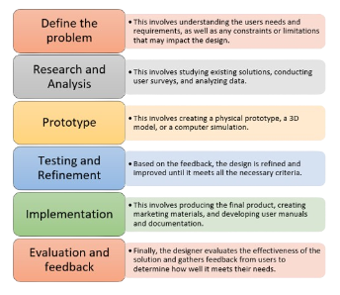

### **3.1.Dataset**

The Posture Guard project's effectiveness stems from its capacity to precisely forecast and avert injuries associated to working out by examining real-time biomechanical data. The dataset is an essential part of the creation of this novel system; it is a carefully selected set of representative and varied samples that forms the basis for the machine learning algorithms' training and validation.

The inclusion of a wide range of exercises that replicate the variety of activities seen in gym settings is the foundation of the dataset. It is important to include weightlifting exercises, cardiovascular workouts, flexibility drills, and functional motions in the machine learning model so that it can fully comprehend the subtleties of different training regimens.

It is critical to have diversity in body positions and movements when building a dataset that performs effectively in a variety of settings. Both static postures like sitting, standing, and lying down as well as dynamic motions like lunges, hops, and squats should be included in the dataset. This diversity guarantees that data from various exercise settings may be interpreted by the machine learning model in an efficient manner. In order to improve the model's capacity to forecast injury risks, the dataset ought to incorporate examples or models of possible damage situations brought on by improper postures. This could entail actions that, if performed incorrectly, could result in sprains, strains, or other injuries, teaching the model to recognize and avoid such circumstances.

Ensuring the inclusivity of the model requires a dataset that reflects a variety of user demographics. It is important to gather samples from people with varying body types, degrees of fitness, and gym-going experiences. This diversity makes it easier to develop a model that serves a wide range of people. Real-time data collecting should ideally take place during actual gym sessions. By exposing the model to the dynamic dynamics of actual gym environments—where individuals perform workouts in a variety of surprising ways—this method enhances the dataset's authenticity.

The dataset should be created with long data collection periods in mind to provide ongoing monitoring. As a result, the model may adjust over time to users' changing posture and movement patterns, guaranteeing that the system will continue to offer pertinent feedback to users as they advance in their fitness journeys.

To sum up, creating the dataset for the Posture Guard project is a thorough and complex process. A thoughtful combination of exercises, practical application, and moral reflection is needed to build a basis that enables the machine learning model to forecast and avert accidents sustained in the gym with precision. This dataset serves as the foundation for the Posture Guard system, which provides a proactive and customised solution for anyone looking to maximise their workouts while lowering their risk of injury.

### **3.2 Pose Estimation using MediaPipe-based Model**:

Google created the open-source Media Pipe framework, which offers resources for creating perceptual computing apps that can do tasks like position estimation, hand tracking, and face detection. When utilising Media Pipe for pose estimation, an individual's poses in photos or videos are usually estimated by identifying important places on their body.

The method makes use of a two-step detector-tracker machine learning pipeline, which we have successfully implemented in our Media Pipe Face Mesh and Media Pipe Hands products. Using a detector, the pipeline first locates the person or posture region-of-interest (ROI) inside the frame. The tracker then predicts the segmentation mask and posture markers within the ROI using the ROI-cropped frame as input. It should be emphasized that in video use cases, the detector is only triggered for the initial frame and in the event that the tracker is not able to identify whether body posture was present in the preceding frame. The ROI for next frames is determined by the pipeline using just the pose landmarks from the previous frame. Using a pose landmark subgraph from the pose landmark module, the pipeline is created as a Media Pipe graph.

As seen in Figure 1, MPP uses a Blaze Pose to extract 33 2D landmarks from the human body. With CPU inference, Blaze Pose is a lightweight machine learning architecture that achieves real-time performance on PCs and mobile devices. In order to estimate a pose using normalised coordinates, multiply the inverse ratio by the pixel values on the y-axis. Based on the calculated MPP landmarks, we estimated arbitrary postures and motions using 12 landmarks (Figure 1), whose indices are 11, 12, 13, 14, 15, 16, 23, 24, 25, 26, 27, and 28.

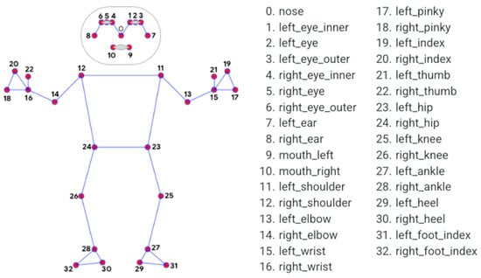

#### **3.3. Movement Analysis**

Posture Guard uses advanced movement analysis algorithms to evaluate how well several joints work together when performing workouts. Through an examination of the connections between joints, the system learns about the efficiency and fluidity of motion. The identification of possible stress points or locations where poor coordination may raise the risk of damage is made possible by this all-encompassing method.

Throughout each workout, the system dynamically records the range of motion (ROM) of the users. Posture Guard finds cases of restricted or excessive motion by comparing observed joint angles to predicted ranges based on biomechanical norms. This knowledge advances our understanding of movement quality and helps to prevent injuries brought on by overextension or inadequate range of motion during exercise.

Exercises are dynamic, and Posture Guard uses acceleration and velocity analysis to capture that. The system evaluates movement abruptness and speed, especially when an exercise is transitioning between stages. Uncontrolled movements may be indicated by sudden accelerations or decelerations, in which case the system can promptly warn users and offer suggestions for safer and more efficient operation.

By adding sophisticated movement analysis, Posture Guard becomes even more powerful and gives consumers a comprehensive view of their training methods. The system becomes a powerful instrument for reducing the risk of injury and encouraging safe and efficient exercise by taking into account multi-joint coordination, range of motion, velocity, acceleration, load distribution, movement patterns, and wearable sensor data.

# EXPERIMENTAL RESULTS

It is anticipated that the Safe and Efficient Gym project will yield noteworthy results in the near and far future. By continuously monitoring the user's exercise regimen and notifying them when problems occur that could be detrimental to their health, the initiative seeks to lessen and avoid injuries sustained during physical activity in the near term. Users will be able to work out safely and effectively with this, maybe improving their physical health right away. The project's long-term goals are to improve physical health and lower the frequency of exercise-related injuries among athletes, both amateur and professional. The idea can help users maintain a healthy lifestyle and prevent long-term health issues linked to physical inactivity or obesity by offering them a safe and efficient workout.

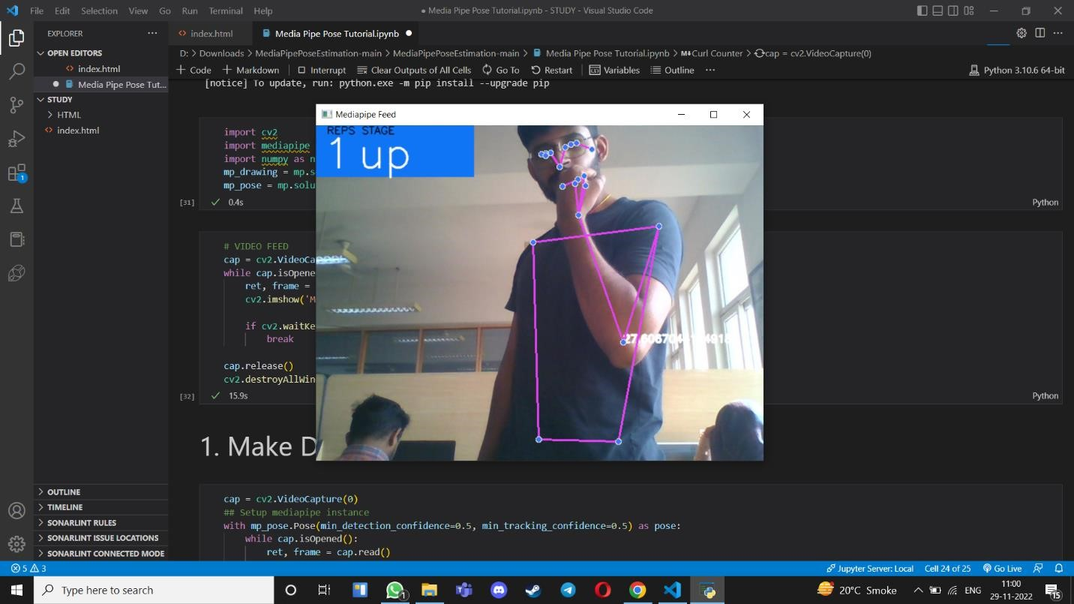

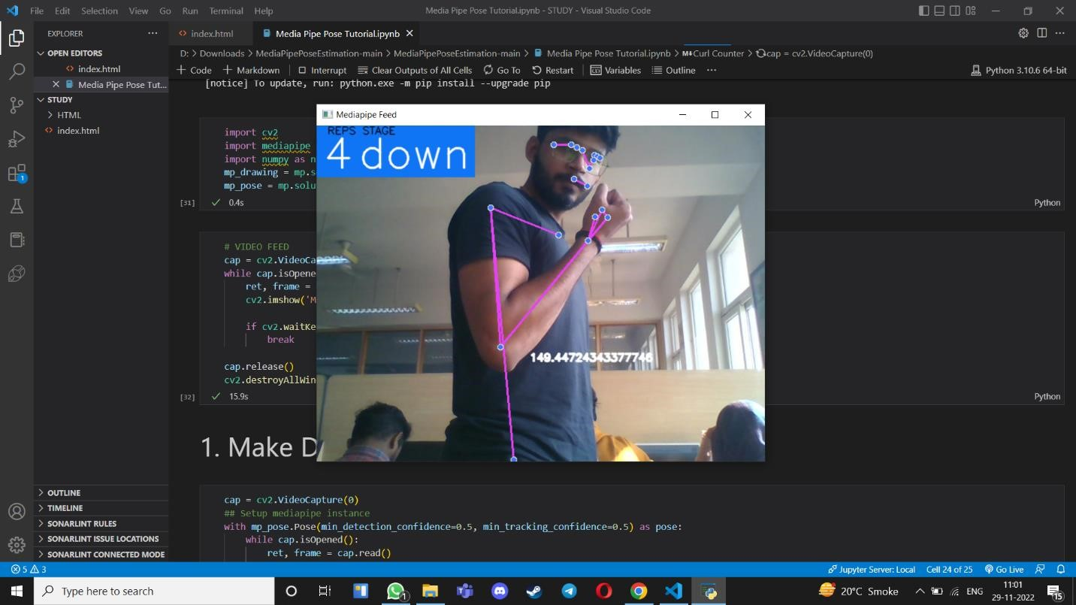

Moreover, the initiative can provide as a foundation for further studies in the fields of injury prevention and exercise monitoring. Researchers can learn more about the elements that lead to exercise-related injuries and create more potent preventative measures by gathering and evaluating data on user habits and exercise regimens. Overall, it is anticipated that the Safe and Efficient Gym project's results will significantly improve physical health and lower the number of injuries related to gyms.

# Conclusion

By using cutting-edge technology to anticipate and prevent injuries, Posture Guard completely transforms gym safety. This cutting-edge device provides individualized input to improve posture and lower the chance of injury by analyzing users' motions in real-time. Posture Guard promotes long-term fitness and well-being by ensuring a safer and more successful workout experience with its proactive approach.

Posture Guard goes above and beyond conventional injury prevention techniques by utilizing the power of predictive analytics to enable users to take proactive measures to address possible dangers before they worsen. The customized aspect of the system guarantees that suggestions and remedial actions are adapted to the distinct requirements and constraints of every user, augmenting the comprehensive efficacy of injury prevention tactics.

Posture Guard is a shining example of innovation in a culture that is becoming more and more concerned with fitness and health, encouraging a proactive and all-encompassing approach to wellbeing. Posture Guard has the power to completely change how we approach injury prevention in the gym and establish new benchmarks for the efficacy and safety of exercise regimens as it develops and adapts to new technology. In summary, Posture Guard is more than simply a tool—it's a guardian that lets people pursue their fitness objectives with assurance since they know that their health comes first and is safeguarded.

# Future Scope

In the future, predicting and preventing injuries at the gym will need combining state-of-the-art technology with personalised health data. In the future, wearable technology will track levels of muscle activity, fatigue, and hydration to deliver risk evaluations in real time. Artificial intelligence will examine vast amounts of data to predict ailments based on workout patterns and biomechanics. Smart fitness equipment with inbuilt sensors will monitor form and provide remedial input to prevent accidents. Predictive analytics will identify overtraining concerns and augmented and virtual reality will guide users in best approach. While data security is crucial, collaborative health platforms will facilitate communication between medical professionals and encourage a more all-encompassing approach to injury care.

##### References

[1] Laplaza, Javier, et al. "Body Gesture Recognition to Control a Social Robot." arXiv preprint arXiv:2206.07538 (2022).

[2] Huang, Xiaoping, et al. "A posture recognition method based on indoor positioning technology." Sensors 19.6 (2019): 1464

[3] Abedi, Wafaa M. Salih, Dr Ibraheem-Nadher, and Ahmed T. Sadiq. "Modified deep learning method for body postures recognition." International Journal of Advanced Science and Technology 29.2 (2020): 3830-3841

[4] Gjoreski, Hristijan, Mitja Lustrek, and Matjaz Gams. "Accelerometer placement for posture recognition and fall detection." 2011 Seventh International Conference on Intelligent Environments. IEEE, 2011.

[5] Dimitrijevic, M., V. Lepetit, and P. Fua. "Human body pose recognition using spatiotemporal templates." ICCV workshop on Modeling People and Human Interaction. No. CONF. 2005.

[6] Song, Yale, David Demirdjian, and Randall Davis. "Continuous body and hand gesture recognition for natural human-computer interaction." ACM Transactions on Interactive Intelligent Systems (TiiS) 2.1 (2012): 1-28.

[7] Gunes, Hatice, Massimo Piccardi, and Tony Jan. "Face and body gesture recognition for a vision-based multimodal analyser." Pan-Sydney Area Workshop on Visual Information Processing. ACS, 2004.

[8] Goldmann, Lutz, Mustafa Karaman, and Thomas Sikora. "Human body posture recognition using MPEG-7 descriptors." Visual Communications and Image Processing 2004. Vol. 5308. SPIE, 2004.

[9] Pisharady, Pramod Kumar, and Martin Saerbeck. "Kinect based body posture detection and recognition system." International Conference on Graphic and Image Processing (ICGIP 2012). Vol. 8768. SPIE, 2013.

[10] Dimitrijevic, Miodrag, Vincent Lepetit, and Pascal Fua. "Human body pose detection using bayesian spatio-temporal templates." Computer vision and image understanding 104.2-3 (2006): 127-139.

[11] Shirehjini, Ali Asghar Nazari, Abdulsalam Yassine, and Shervin Shirmohammadi. "Design and implementation of a system for body posture recognition." Multimedia tools and applications 70 (2014): 1637-1650.

[12] Van den Bergh, Michael, Esther Koller-Meier, and Luc Van Gool. "Real-time body pose recognition using 2D or 3D haarlets." International journal of computer vision 83 (2009): 72-84.

[13] Hock, Alyson, et al. "The whole picture: Holistic body posture recognition in infancy." Psychonomic Bulletin & Review 23 (2016): 426-431.

[14] Hu, Fengye, et al. "A human body posture recognition algorithm based on BP neural network for wireless body area networks." China Communications 13.8 (2016): 198-208.

[15] Daems, Anja, and Karl Verfaillie. "Dependent priming effects in the perception of human actions and body postures." Visual cognition 6.6 (2019): 665-693.

[16] Walters, Kathy L., and Richard D. Walk. "Perception of emotion from moving body cues in photographs." Bulletin of the Psychonomic Society 26.2 (2009): 112-114.

[17] Coulson, Mark. "Attributing emotion to static body postures: Recognition accuracy, confusions, and viewpoint dependence." Journal of nonverbal behavior 28 (2004):117-139